Script to validate Tempdb configuration in SQL Server

Introduction
This T-SQL sample script illustrates how to check tempdb configuration per best practices.
Tempdb is a system database is highly used by Sql Server and an optimal tempdb configuration is generally important for smooth running of the Sql instance.

Scenarios
Ideal tempdb configuration is a frequently asked question by IT administrators in the TechNet forums.
IT professionals want to check tempdb best practices by script, for example,
- Checking current number of tempdb data files
- Suggesting ideal number of tempdb data files (subject to testing).
- Checking if tempdb files are created of equal size.
- Checking if tempdb files are created of equal growth (increment and type).
- Checking if tempdb trace flag (for uniform extent allocation) is enabled & required depending on Sql version
- Suggesting if tempdb configuration is healthy if no suggestions were made
- Ability to run script in Sql 2005/2008/2008R2/2012.

Script
Please open a new query window in Sql Server Management Studio.
Please paste the entire script in the query window and then please Execute the script.
A sample output is indicated below for reference
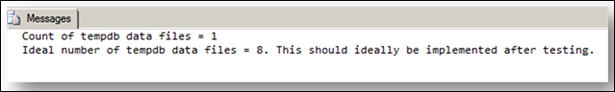
https://gallery.technet.microsoft.com/scriptcenter/Script-to-validate-Tempdb-4c988afa

